Module 2
Control Statements and Functions:Control Statements: If Else Statement, Switch Statement, Break Statement, Continue Statement, Looping Structures - While Statement, Do-while Statement, For Statement Functions.Defining A Function, Accessing A Function, Function Prototypes, Passing Arguments To A Function, Return Values And Their Types ,Category Of Functions.Recursion, Storage Classes: Automatic Variables, External, Variables, Static Variables, Register Variable.

Control flow statements in Programming
Control flow refers to the order in which statements within a program execute. While programs typically follow a sequential flow from top to bottom, there are scenarios where we need more flexibility. This article provides a clear understanding about everything you need to know about Control Flow Statements.
Control flow statements are fundamental components of programming languages that allow developers to control the order in which instructions are executed in a program. They enable execution of a block of code multiple times, execute a block of code based on conditions, terminate or skip the execution of certain lines of code, etc.
Types of Control Flow statements in Programming:
Control Flow Statements Type | Control Flow Statement | Description
Conditional Statements | if-else | Executes a block of code if a specified condition is true, and another block if the condition is false.
Conditional Statements | switch-case | Evaluates a variable or expression and executes code based on matching cases.
Looping Statements | for | Executes a block of code a specified number of times, typically iterating over a range of values.
Looping Statements | while | Executes a block of code as long as a specified condition is true.
Looping Statements | do-while | Executes a block of code once and then repeats the execution as long as a specified condition is true.
Jump Statements | break | Terminates the loop or switch statement and transfers control to the statement immediately following the loop or switch.
Jump Statements | continue | Skips the current iteration of a loop and continues with the next iteration.
Jump Statements | return | Exits a function and returns a value to the caller.
Jump Statements | goto | Transfers control to a labeled statement within the same function. (Note: goto is generally discouraged due to its potential for creating unreadable and error-prone code.)

Conditional Statements in Programming
Conditional statements help a program make decisions. They check whether a condition is true or false and execute different blocks of code based on the result. This allows programs to behave differently in different situations.
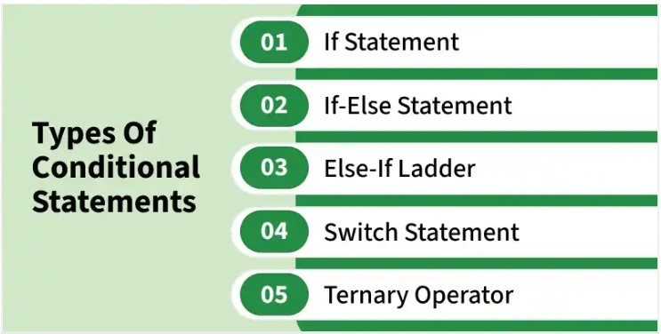
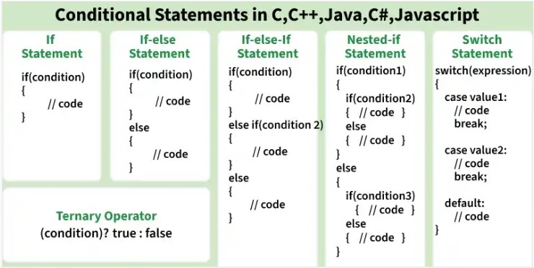
If Conditional Statement: The if statement checks a condition and executes a block of code only when the condition is true.
#include <stdio.h>
int main()
{
int x = 7;
if (x > 0)
{
printf("x is positive");
}
return 0;
}
Output
x is positive
If-Else Conditional Statement
The if-else statement checks a condition and runs one block of code if the condition is true, and another block of code if the condition is false.
Flowchart of If-Else Statement
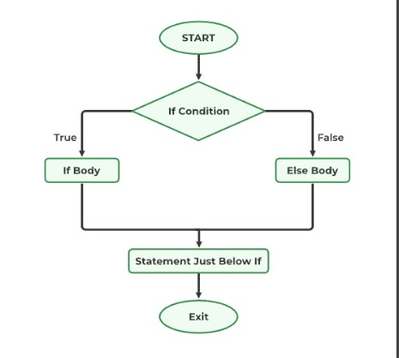
#include <stdio.h>

int main()
{
int x = 7;
if (x > 0)
{
printf("x is positive");
}
else
{
printf("x is not positive");
}
return 0;
}
Output
x is positive
if-Else if Conditional Statement
The if-else if statement is used to check multiple conditions. The program evaluates each condition one by one and executes the block of code for the first condition that is true.
Flowchart of If-Else if Statement
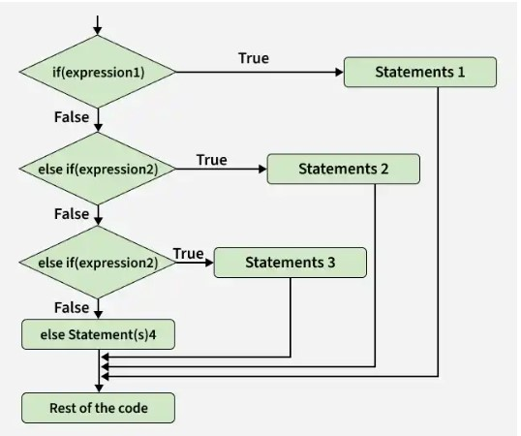
#include <stdio.h>
int main()
{
int x = 0;
if (x > 0)
{
printf("x is positive");
}
else if (x)
{
printf("x is negative");
}
else
{
printf("x is zero");
}
return 0;
}
Output
x is zero
Switch Conditional Statement
The switch statement checks a variable against multiple possible values. Each option is written as a case, and the program executes the matching case. A break statement is usually used to stop execution after a case runs.
Flowchart of Switch Statement
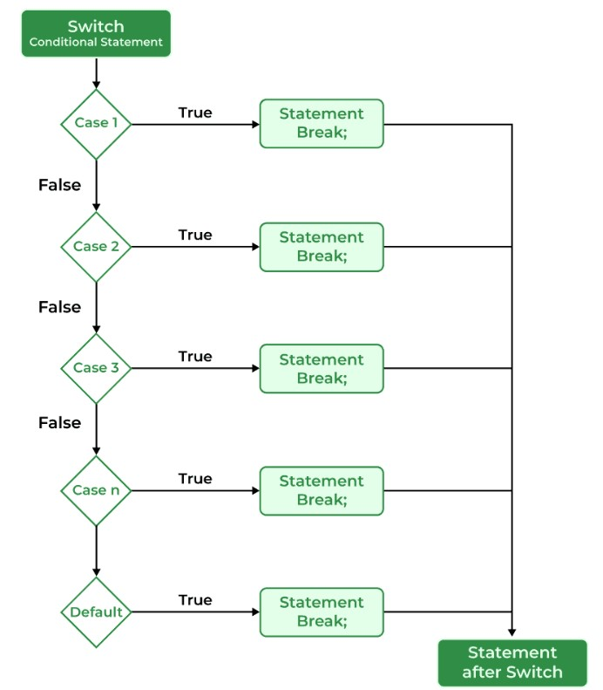
Rules of the Switch Statement
When using switch statements, there are a few important rules.
- Case values must be constant values.
- Duplicate case values are not allowed.
- A switch statement can contain multiple case blocks.
- The break statement is optional, but recommended to prevent fall-through.
- The default case is optional but useful for handling unexpected values
#include <stdio.h>
int main() {
int day = 2;
switch (day) {
case 1:
printf("Monday\n");
break;
case 2:
printf("Tuesday\n");
break;
case 3:
printf("Wednesday\n");
break;
default:
printf("Invalid day!\n");
}
return 0;
}
Output
Tuesday
Jump Statements in Programming:
Jump statements in programming are used to change the flow of control within a program. They allow the programmer to transfer program control to different parts of the code based on certain conditions or requirements. Here are common types of jump statements:
1. Break Statement in Programming:
The break statement is primarily used to exit from loops prematurely. When encountered inside a loop, it terminates the loop's execution and transfers control to the statement immediately following the loop.
#include <stdio.h>
int main()
{
for (int i = 0; i < 10; i++) {
if (i == 5)
break;
printf("%d ", i);
}
return 0;
}
Output
0 1 2 3 4
2. Continue Statement in Programming:
The continue statement is used to skip the current iteration of a loop and proceed to the next iteration.
#include <stdio.h>

int main()
{
for (int i = 0; i < 10; i++) {
if (i % 2 == 1)
continue;
printf("%d ", i);
}
return 0;
}
Output
0 2 4 6 8
3. Return Statement in Programming:
The return statement is used to exit a function and optionally return a value to the caller.
#include <stdio.h>
int isEven(int N) { return N % 2 == 0; }
int main()
{
int N = 5;
if (isEven(N)) {
printf("N is even");
}
else {
printf("N is odd");
}
return 0;
}
Output
N is odd

4. Goto Statement in Programming:
Some programming languages support the goto statement, which allows transferring control to a labeled statement within the same function or block of code. However, the use of goto is generally discouraged due to its potential for creating unreadable and unmaintainable code.
#include <stdio.h>
int main() {
int i = 0;
loopStart:
if (i < 5) {
printf("%d ", i);
i++;
goto loopStart;
}
return 0;
}
Output
0 1 2 3 4

Loops in C
In C programming, there is often a need for repeating the same part of the code multiple times. For example, to print a text three times, we have to use printf() three times as shown in the code:
#include <stdio.h>
int main() {
printf( "Hello GfG\n");
printf( "Hello GfG\n");
printf( "Hello GfG");
return 0;
}
Output
Hello GfG
Hello GfG
Hello GfG

But if we say to write this 20 times, it will take some time to write statement. Now imagine writing it 100 or 1000 times. Then it becomes a really hectic task to write same statements again and again. To solve such kind of problems, we have loops in programming languages.
In the following code, we have used a loop to print text 3 times. We could have done it for 100 or even 1000 times in the same number of code lines.
#include <stdio.h>
int main() {
// Loop to print "Hello GfG" 3 times
for (int i = 0; i < 3; i++) {
printf("Hello GfG\n");
}
return 0;
}
Output
Hello GfG
Hello GfG
Hello GfG
Types of loops in C
Loops in C programming are used to repeat a block of code until the specified condition is met. It allows programmers to execute a statement or group of statements multiple times without writing the code again and again.
There are 3 looping statements in C:

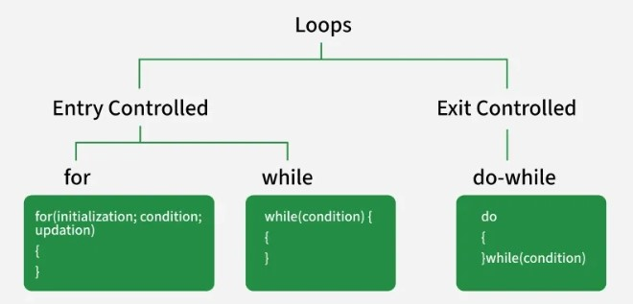

for Loop
for loop is an entry-controlled loop, which means that the condition is checked before the loop's body executes.
Syntax
for (initialization; condition; updation) {
// body of for loop
}
The various parts of the for loop are:
- Initialization: Initialize the variable to some initial value.
- Test Condition: This specifies the test condition. If the condition evaluates to true, then body of the loop is executed. If evaluated false, loop is terminated.
- Update Expression: After the execution loop’s body, this expression increments/decrements the loop variable by some value.
- Body of Loop: Statements to repeat. Generally enclosed inside {} braces.
Example:
#include <stdio.h>
int main() {
// Loop to print numbers from 1 to 5
for (int i = 0; i < 5; i++) {
printf( "%d ", i + 1);
}
return 0;
}
Output
1 2 3 4 5

Flowchart of for Loop
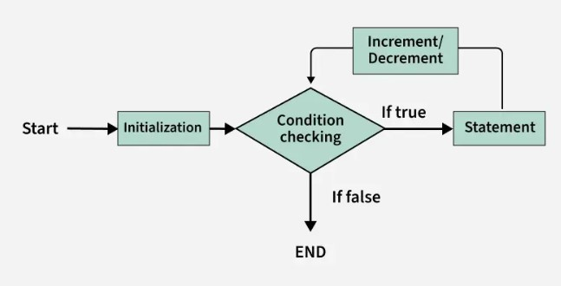
while Loop
A while loop is also an entry-controlled loop in which the condition is checked before entering the body.
Syntax
while (condition) {
// Body of the loop
}
Only the condition is the part of while loop syntax, we have to initialize and update loop variable manually.
Example:
#include <stdio.h>
int main() {
// Initialization expression
int i = 0;
// Test expression
while(i <= 5) {
printf("%d ", i + 1);
// update expression
i++;
}
return 0;
}

Output
1 2 3 4 5 6
Flowchart of while Loop
The below flowchart demonstrates execution flow of the while loop.
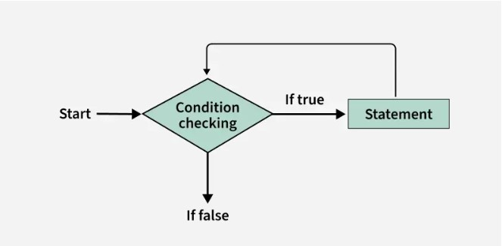
do-while Loop
The do-while loop is an exit-controlled loop, which means that the condition is checked after executing the loop body. Due to this, the loop body will execute at least once irrespective of the test condition.
Syntax
do {
// Body of the loop
} while (condition);
Like while loop, only the condition is the part of do while loop syntax, we have to do the initialization and updating of loop variable manually.
Example:
#include <stdio.h>
int main() {
// Initialization expression
int i = 0;
do
{
// loop body
printf( "%d ", i);
// Update expression
i++;
// Condition to check
} while (i <= 10);
return 0;
}
Output
0 1 2 3 4 5 6 7 8 9 10
Flowchart of do-while Loop
The below flowchart demonstrates execution flow of the do while loop.
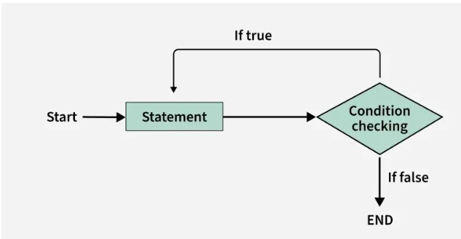
Functions
One of the important strengths of the C programming language is its support for functions. Functions make a program easier to write, understand, test, debug, and reuse.
A function is a self-contained block of statements designed to perform a particular task.
#include <stdio.h>
int main()
{
printf("Hello World");
return 0;
}
In this program:
- main() is a function.
- printf() is a function provided by the C library.
Similarly, scanf() is also a function.
A function is a named block of code that performs a specific task. A function can take inputs (called parameters), execute a block of statements, and optionally return a result.
- A function allows you to write a piece of logic once and reuse it wherever needed in the program.
- This helps keep your code clean, organized, easier to understand and manage.
#include <stdio.h>
// function definition
int square(int x)
{
return x * x;
}
int main()
{
// Calling the function
int result = square(5);
printf("Square of 5 is: %d", result);
return 0;
}
Output
Square of 5 is: 25
Syntax
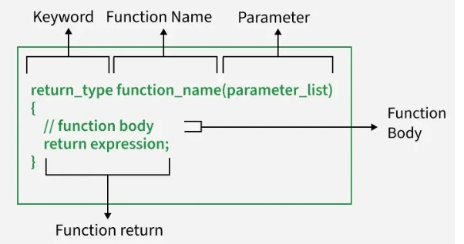
- Return type: Specifies the type of value the function will return. Use void if the function does not return anything.
- Function name: A unique name that identifies the function. It follows the same naming rules as variables.
- Parameter list: A set of input values passed to the function. If the function takes no inputs, this can be left empty or written as void.
- Function body: The block of code that runs when the function is called. It is enclosed in curly braces { }.
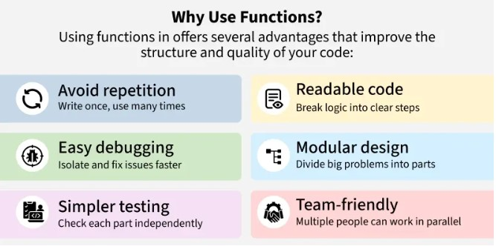
Functions provide several advantages in program development.
1 Modularity
A large program can be divided into smaller, manageable functions.
For example:
Student Management System
|
├── addStudent()
├── displayStudent()
├── searchStudent()
└── deleteStudent()
Each function performs a specific task.
2 Code Reusability
A function can be called multiple times from different parts of a program.
display();
display();
display();
The same code does not have to be written three times.
3 Easy Debugging
If an error occurs in a particular task, we can examine the corresponding function instead of checking the entire program.
4 .Easy Maintenance
Functions make programs easier to modify and maintain.
For example, if the calculation of salary changes, we can modify the salary calculation function without changing the entire program.
5 Better Readability
Dividing a large program into meaningful functions makes the program easier to understand.
Function Declaration Vs Definition
It's important to understand the difference between declaring a function and defining it. Both play different roles in how the compiler understands and uses your function.
Function Declaration
A declaration tells the compiler about the function's name, return type, and parameters before it is actually used. It does not contain the function's body. This is often placed at the top of the program or in a header file.
int add(int a, int b);
Function Definition
A definition provides the actual implementation of the function. It includes the full code or logic that runs when the function is called.
int add(int a, int b) {
return a + b;
}
Calling a Function
Once a function is defined, you can use it by simply calling its name followed by parentheses. This tells the program to execute the code inside that function.
#include <stdio.h>
// Function definition
int add(int a, int b) {
return a + b;
}
int main() {
// Function call
int result = add(5, 3);
printf("The sum is: %d", result);
return 0;
}
Output
The sum is: 8
Explanation
- The add() function is called with the values 5 and 3, computes their sum, and returns the result, which is stored in the variable result.
- A function can be called multiple times from main() or other functions, allowing the same code to be reused whenever needed.
- Function calls improve code reusability, reduce duplication, and make programs easier to read, maintain, and debug.
Types of Function in C
In C programming, functions can be grouped into two main categories: library functions and user-defined functions. Based on how they handle input and output, user-defined functions can be further classified into different types.
Library Functions
These are built-in functions provided by C, such as printf(), scanf(), sqrt(), and many others. You can use them by including the appropriate header file, like #include <stdio.h> or #include <math.h>.
User-Defined Functions
These are functions that you create yourself to perform specific tasks in your program. Depending on whether they take input or return a value, they can be of four types:
- No arguments, no return value: The function neither takes input nor returns any result.
- Arguments, no return value: The function takes input but does not return anything.
- No arguments, return value: The function does not take input but returns a result.
- Arguments and return value: The function takes input and returns a result.
Each type serves different purposes depending on what the program needs. Using the right type helps make your code more organized and efficient.
Memory Management of Functions
When a function is called, the system allocates memory for its parameters and local variables in a stack frame, which is automatically released when the function finishes execution.
- Automatic Memory Allocation: Each function call creates a separate stack frame to store its local variables, parameters, and return information.
- Automatic Memory Deallocation: Once the function returns, its stack frame is removed from the call stack, freeing the allocated memory automatically.
Function Prototypes
A function prototype is a declaration of a function that tells the compiler about the function before the function is actually called.
Example
int add(int, int);
This is a function prototype.
It tells the compiler:
- add → function name
- int before add → function returns an integer
- (int, int) → function accepts two integer arguments
It does not contain the actual implementation.
#include <stdio.h>
int add(int, int); // Function prototype
int main()
{
int result;
result = add(10, 20);
printf("%d", result);
return 0;
}
int add(int a, int b) // Function definition
{
return a + b;
}
Two Main Parts of a Function Definition
A function definition has two major parts:
Function Definition
1.Function Header
2.Function Body
Function Header
The function header contains:
- Return type
- Function name
- Formal parameter list
Example:
int sum(int a, int b)
Function Body
The function body is enclosed within { }.
It contains:
- Local declarations
- Executable statements
- Return statement, when required
Example:
{
int result;
result = a + b;
return result;
}
Function Header
Consider:
float mul(float x, float y)
The three components are:
float mul (float x, float y)
↓ ↓ ↓
Return Function Formal
type name parameters

Function Type / Return Type
The return type specifies the type of value returned by the function.
Examples:
1.int sum(int a, int b)
returns an int.
2.float average(float a, float b)
returns a float.
3.double power(double x, int n)
returns a double.
void Return Type
When a function does not return any value, its return type should be void.
Example:
void printMessage(void)
{
printf("Welcome");
}
Here:
- First void → function does not return a value.
- Second void → function does not accept parameters.
If a function does not return a value, use:
void
Example:
void display(void)
{
printf("Hello");
}

Function Name
A function name is an identifier.
Therefore, it must follow the rules of C identifiers.
Examples:
sum()
calculateTotal()
DisplayResult()
findMaximum()
A meaningful function name should describe the task performed by the function.
For example:
calculateAverage()
is better than:
fun1()
It is also advisable to avoid names that conflict with library functions or other identifiers.
Formal parameters are variables declared in the function header that receive values from the calling function.
Example:
int sum(int a, int b){
}
Here:
a and b → Formal parameters
When the function is called:
sum(10, 20);
the values are passed to the parameters.
10 ─────→ a
20 ─────→ b
Then:
return a + b;
produces:
30
Actual Parameters
Actual parameters are the values or variables supplied to a function when the function is called.
They are also commonly called actual arguments.
Example
int add(int a, int b)
{
return a + b;
}
int main()
{
int result;
result = add(10, 20);
}
Here:
add(10, 20);
- 10 → actual parameter
- 20 → actual parameter
- a and b → formal parameters
Another example
int multiply(int x, int y)
{
return x * y;
}
int main()
{
int a = 5, b = 4;
multiply(a, b);
}
Here:
- a and b → actual parameters
- x and y → formal parameters
Consider:
int sum(int a, int b)
{
return a + b;
}
int main()
{
sum(10, 20);
}
Function Without Parameters
A function does not always need to receive data from the calling function.
Example:
void printline(void)
{
printf("--------------------");
}
Here, the function has no parameters.
The keyword void inside the parentheses explicitly indicates that the function accepts no arguments.
Calling it:
printline();
Function Body
The function body is enclosed within braces:
{
...
}
It generally contains three components:
1. Local declarations
Variables required by the function are declared here.
int i, sum;
2. Function statements
These statements perform the required task.
sum = a + b;
3. Return statement
The result can be returned to the calling function.
return sum;
Return Values And Their Types
A function may or may not return a value to the calling function. When a function needs to send a result back, it uses the return statement.
A function can receive any number of input values through parameters, but one function call can return at most one value.
1. Syntax of the return Statement
There are two basic forms:
return;
and
return expression;
2. Plain return Statement
The statement
return;
does not return a value. It immediately terminates the execution of the current function and transfers control back to the calling function.
Example
void check(int error)
{
if(error)
return;
printf("No error");
}
If error is non-zero, the return statement is executed and the function ends immediately.
3. return with an Expression
The second form is:
return expression;
The expression is evaluated, and its value is sent back to the calling function.
Example
int multiply(int x, int y)
{
int p;
p = x * y;
return p;
}
If we call:
int result;
result = multiply(5, 4);
The function calculates:
p = 5 × 4
p = 20
and:
return p;
returns 20 to the calling function.
4. Direct Return of an Expression
The following:
p = x * y;
return p;
can be simplified to:
return (x * y);
Complete example:
int multiply(int x, int y)
{
return (x * y);
}
This is more concise because the calculated result is returned directly.
5. A Function Can Have Multiple return Statements
A function can contain more than one return statement.
This is useful when the value to be returned depends on a condition.
Example
int maximum(int a, int b)
{
if(a > b)
return a;
else
return b;
}
Here, there are two possible return statements:
a > b
|
├── Yes → return a
|
└── No → return b
However, only one of them will be executed during a particular function call.
CATEGORY OF FUNCTIONS
A function, depending on whether arguments are present or not and whether a value is returned or not, may belong to one of the following categories:
Category 1: Functions with no arguments and no return values.
Category 2: Functions with arguments and no return values.
Category 3: Functions with arguments and one return value.
Category 4: Functions with no arguments but return a value.
Category 5: Functions that return multiple values.
1. Function with No Arguments and No Return Value
This type of function:
- Does not receive any data from the calling function.
- Does not return any value.
- Performs its task independently.
Example
#include <stdio.h>
void display(void)
{
printf("Welcome to C Programming");
}
int main()
{
display();
return 0;
}
Here:
void display(void)
- First void → no return value
- Second void → no arguments
2. Function with No Arguments but With Return Value
This type of function:
- Does not receive arguments.
- Performs some operation.
- Returns a value to the calling function.
Example
#include <stdio.h>
int getNumber(void)
{
int n;
printf("Enter a number: ");
scanf("%d", &n);
return n;
}
int main()
{
int number;
number = getNumber();
printf("Number = %d", number);
return 0;
}
Here:
int getNumber(void)
- void → no arguments
- int → returns an integer
The returned value is received by:
number = getNumber();
3. Function with Arguments but No Return Value
This type of function:
- Receives data from the calling function.
- Performs an operation.
- Does not return a value.
Example
#include <stdio.h>
void displaySum(int a, int b)
{
int sum;
sum = a + b;
printf("Sum = %d", sum);
}
int main()
{
displaySum(10, 20);
return 0;
}
Here:
displaySum(10, 20);
10 and 20 are actual arguments.
They are received by:
void displaySum(int a, int b)
where a and b are formal parameters.
The function displays the result but does not return it.
4. Function with Arguments and With Return Value
This is one of the most commonly used forms.
The function:
- Receives data through arguments.
- Performs an operation.
- Returns a value to the calling function.
Example
#include <stdio.h>
int add(int a, int b)
{
return a + b;
}
int main()
{
int result;
result = add(10, 20);
printf("Sum = %d", result);
return 0;
}
Here:
10, 20 → Actual arguments
a, b → Formal parameters
30 → Return value
Storage Classes
A variable is a named memory location used to store data that may change during program execution.
A variable in C has:
- Data type – specifies what type of data it stores.
- Storage class – specifies its scope, lifetime, and visibility.
For example:
int count;
Here:
- int → data type
- count → variable name
A storage class can also be specified:
static int count;
Here, static is the storage class specifier.
Scope of a Variable
Scope refers to the portion of a program where a variable can be accessed or recognized.
Variables are broadly classified as:
- Global variables
- Local variables
Global Variables
A variable declared outside all functions is called a global variable.
Example:
#include <stdio.h>
int m = 10;
void display()
{
printf("%d", m);
}
int main()
{
printf("%d", m);
display();
return 0;
}
Here:
int m = 10;
is a global variable.
It can be accessed by functions in the same source file, subject to normal scope/linkage rules.
Global variables are also commonly referred to as external variables.
Local Variables
A variable declared inside a function is called a local variable.
Example:
void calculate()
{
int sum;
int balance;
}
Here:
sum
balance
are local variables.
They can be accessed only within the function/block where they are declared.
Example
#include <stdio.h>
void function1()
{
int i = 10;
printf("%d", i);
}
void function2()
{
int i = 20;
printf("%d", i);
}
Although both functions have a variable named i, they are different variables.
Changing i in function1() does not change i in function2().

A storage class in C specifies the scope, lifetime, visibility, and storage location of a variable.
In simple words, storage class tells us:
- Where a variable can be accessed
- How long the variable exists
- What its default value is
- Whether it can be accessed from other functions/files
The main storage classes in C are:
- auto – Automatic variables
- extern – External variables
- static – Static variables
- register – Register variables

Examples
auto int count;
register char ch;
static int x;
extern long total;

